- Once the Offer is sent to Buyer , the Buyer will login to the session Enquiry in Process .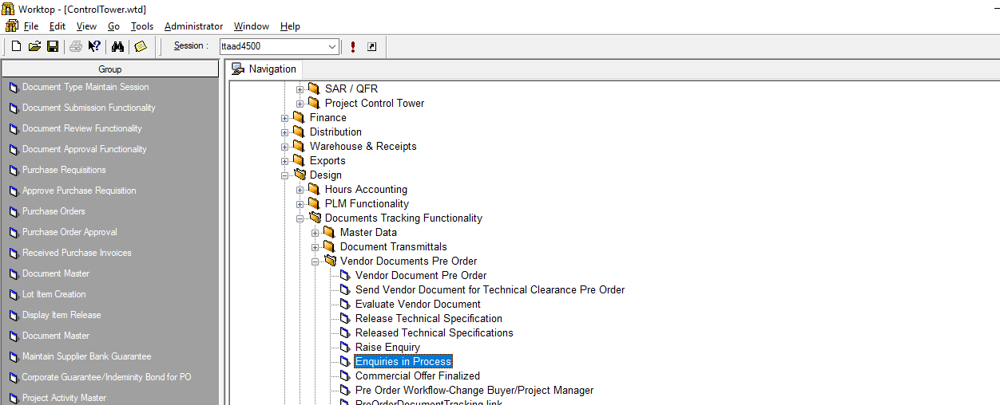
Select Session

- Select View Enquiry in the screen that opens up.
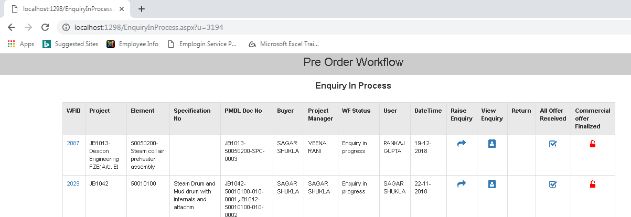
Select View Enquiry
- Click on WFID against that Enquiry
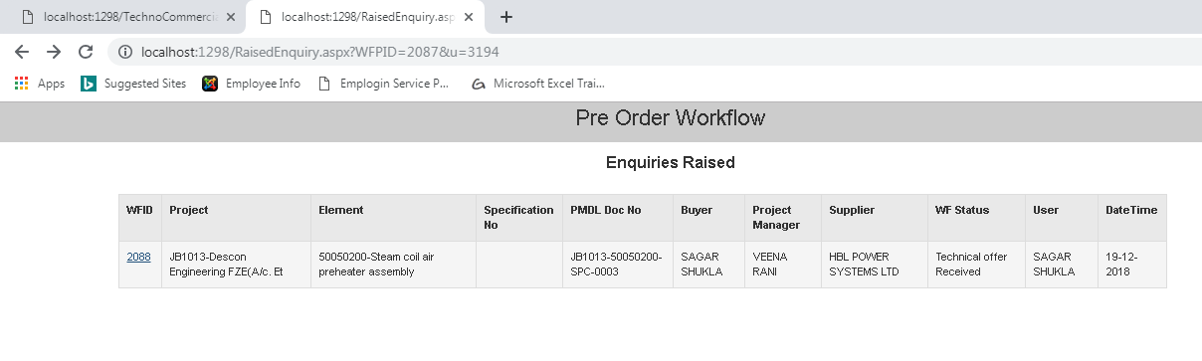
Select WFID

- In the screen that opens up click on Technical Offer Received Button
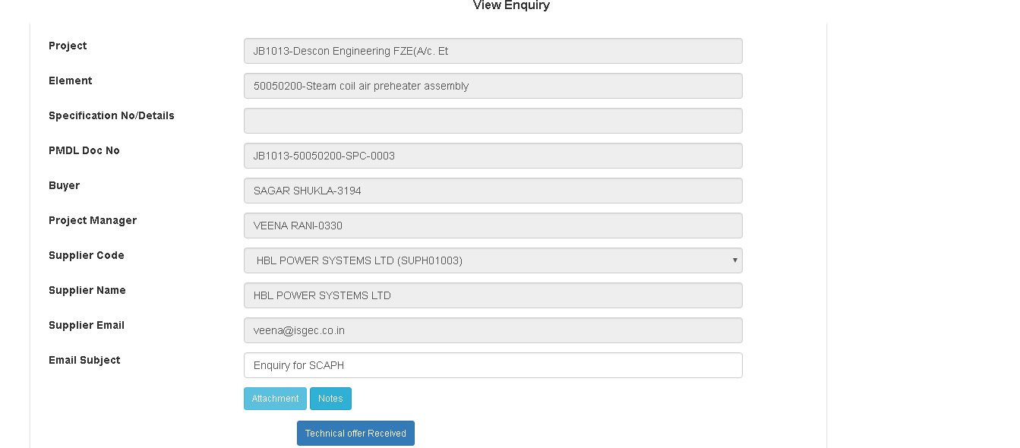
Technical Offer Received
- In The Screen that Open up the Status will change to Technical Offer Received.
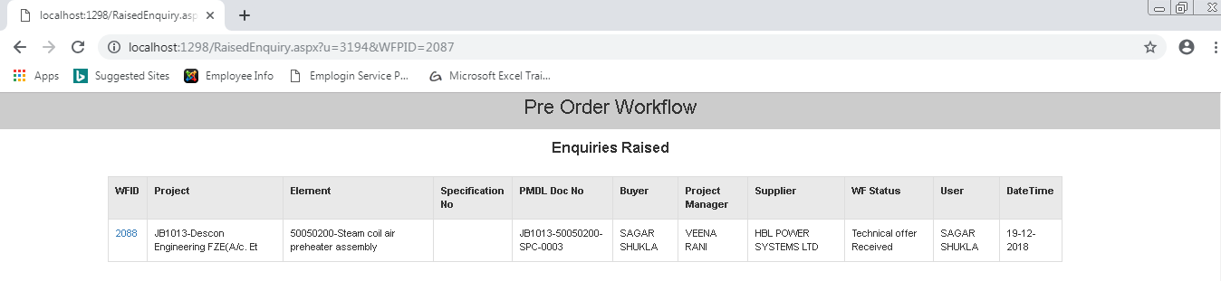
Status Changed

